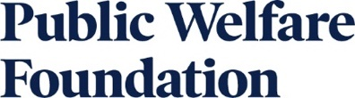

PROGRESS Report Reference Form

*Please note that the progress report will be part of the Renewal application.
Instructions

All reports are completed and submitted through our grants management database. This form can be used as reference of the questions on the portal, but please do not use this form to submit the final report.

Progress Reports are only if you are a current grantee who has been invited to apply for renewal funding.

Narrative instructions:

- For multi-year grants, you must report on the work of the entire grant period.

- Please answer the following questions. Please refer to the proposal you submitted to the Foundation in writing this report.

1. What activities did you conduct during the grant period, including those not anticipated in your original proposal? What activities did you decide not to undertake?

2. What did you achieve during the grant period?

4. Provide reflection on challenges faced and/or strategic lessons learned and, if applicable, your plans to adjust strategy moving forward.

Optional:

5. Are there any partnerships you want to highlight?

6. Have there been any significant changes (positive or negative) in your organizational capacity during the grant period? What staff changes have occurred?

Financial Information:

Provide the following information about receipt and expenditure of your PWF grant for the time period covered by this report:

- For general support grants, provide a financial statement listing your organization’s actual income and expenditures for the time period covered by this report.

- For project support grants, please provide the project’s actual income and a line-by-line reconciliation of the actual project expenditures with the approved project budget that was submitted with the proposal and note any modifications that were made. (Please see the sample financial reporting template available on our website).

